ESSENTIAL INFORMATION FOR ALATEENS AND THEIR PARENTS OR GUARDIANS
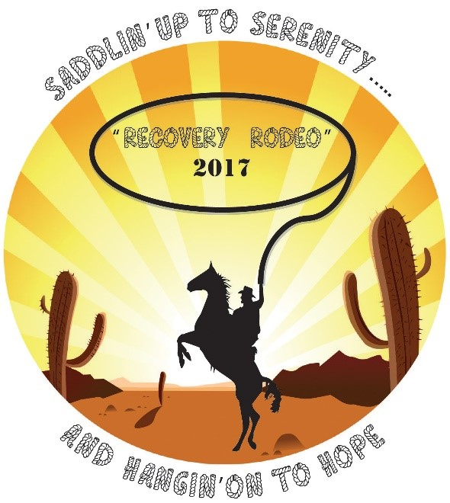
All Alateens must register for the convention in advance. Each Alateen and his/her parent or guardian must PRINT, COMPLETE AND SUBMIT the “Information and Permission Form,” the Medical Form
(http://www.al-anon.org/members/pdf/guidelines/G34.pdf)
Clicking the above link will take you to another web site: al-anon.org.

And the “Alateen Behavioral and Safety Requirements Form”
(www.afgarea9.org/convention2017/Alateenbehavioralsafety2017.pdf)

Feel free to download the forms above to distribute at your meetings.

Please note: All Alateen activities and workshops are limited to Alateen members and prospective members.

We will NOT be responsible for Alateens beyond the time allocated (5:00 pm Saturday), so it will be the responsibility of the adult to watch his or her Alateen. The Alateens are welcome to attend open Al-Anon workshops.

Al-Anon Members Involved in Alateen Service (AMIAS) will supervise teens and preteens at all times from 9:00 am to 5:00 pm on Saturday, August 26, 2017 only. The teens may be dropped off and left for that entire time. A parent or guardian may check their teen out at any time. A parent or notarized guardian must pick up participants by 5:00 pm at the location to be announced.

Various recreational options will be available to teens accompanied by an adult between 9:00 am-5:00 pm. Again, a parent or guardian may check their teen out at any time.

Alateen speakers will be sharing their stories on Friday evening.

Alateens are welcome to participate in all convention activities in addition to the Alateen events.

If you have any questions or need more information, contact our 2017 Convention Alateen Chairperson, Sharon N. (Contact info to come.)

