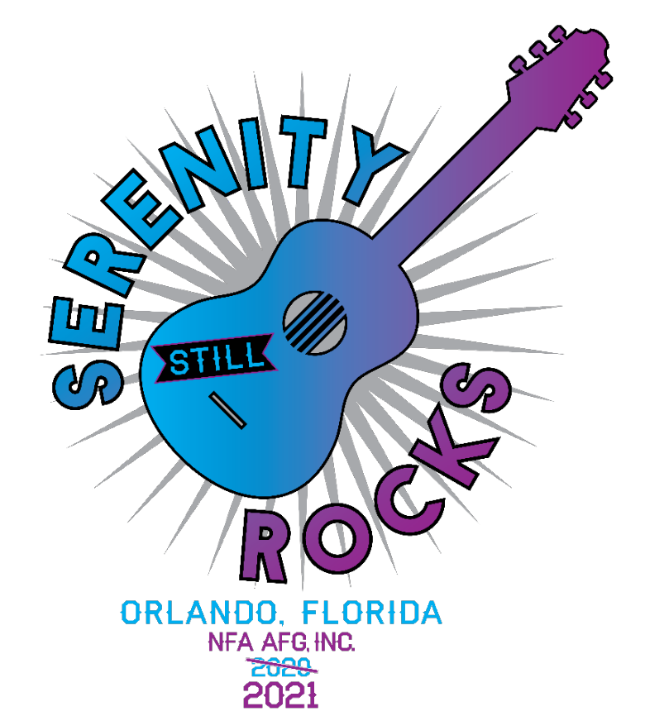

31st Florida North AFG

2021 Convention

August 27-29, 2021

Hosted By District 10

* Al-Anon, Alateen & AA Speakers
* Al-Anon, Alateen & AA Workshops
* Spanish Workshops ~ Talleres en Español
* Conference Approved Literature (CAL)
* Serenity Room

https://www.afgarea9.org/convention2020

* Boutique
* Banquet
* Entertainment
* Basket Raffle
* 50/50 Raffle

Register Today!

$35 Adults / $10 Alateens*

Online/Pre-Registration Closes 8/18/20

On-Site registration $45 Adults / $10 Alateens

[www.afgarea9.org/convention2020](http://www.afgarea9.org/convention2020)

*Alateen registration includes a Pizza Party!

Alateens MUST download & bring the required paperwork to the 2021 Convention

Special Hotel Room Rate Ends 8/7/21

Hilton Orlando Buena Vista Palace  
1900 E. Buena Vista Drive  
Lake Buena Vista, FL 32830  
407-827-2727

Ask for the “2021 NFA AFG Convention” rate for the contracted room rate of $140.00 per night (includes resort fee).

50% discount on Hotel parking –  
 approx. $11.00 per day/night.

Free parking at Disney Springs.